

**Planet Heat**



Project Name: Planet Heat

**Introduction:**

It is a AI base global temperature prediction dashboard those provide a result on a base of old data from 1750 to Current 2024 It is show you worldwide average land temperature expressed in Celsius. Indicates the 95% certainty level surrounding mean land temperature values. Depicts worldwide average maximum land temperature measured in Celsius plies the 95% certainty degree associated with maximum land temperature readings. Expresses global average minimal land temperature denoted in Celsius. Symbolizes the 95% reliability margin linked to minimal land temperature findings Signifies global average combined land and ocean temperature . specified in Celsius. Embodies the corresponding 95% uncertainty scope attributed to blended land and oceanic temperature estimations.

Contents

**Problem Definition** 3

**Design Specifications** 3

**Diagrams** 3

**Dialog Flow** 8

**Test Data Used in the Project** 9

**Project Installation Instructions** 9

**Steps to Execute the Project** 9

**Problem Definition**

The **Planet Heat** application aims to provide an interactive platform for analyzing historical Earth surface temperature data and predicting future temperature trends. By utilizing machine learning techniques, the app helps users understand climate patterns and informs decision-making regarding climate adaptation and mitigation.

**Design Specifications**

* **Input:** Year (between 1750 and 2100) for temperature predictions.
* **Output:**
  + Charts displaying historical temperature trends.
  + Predicted temperatures for the specified year.
* **Technologies Used:**
  + Python
  + Dash (for web application framework)
  + Plotly (for data visualization)
  + Scikit-learn (for machine learning model)
  + Pandas (for data manipulation)

**Diagrams**

**Land Average Temperature:**

* Represents the global average temperature measured solely over land surfaces.
* Expressed in degrees Celsius, it tracks the variations and trends in land temperature over time.
* A critical indicator of climate change impacts, especially on terrestrial ecosystems and human habitats.

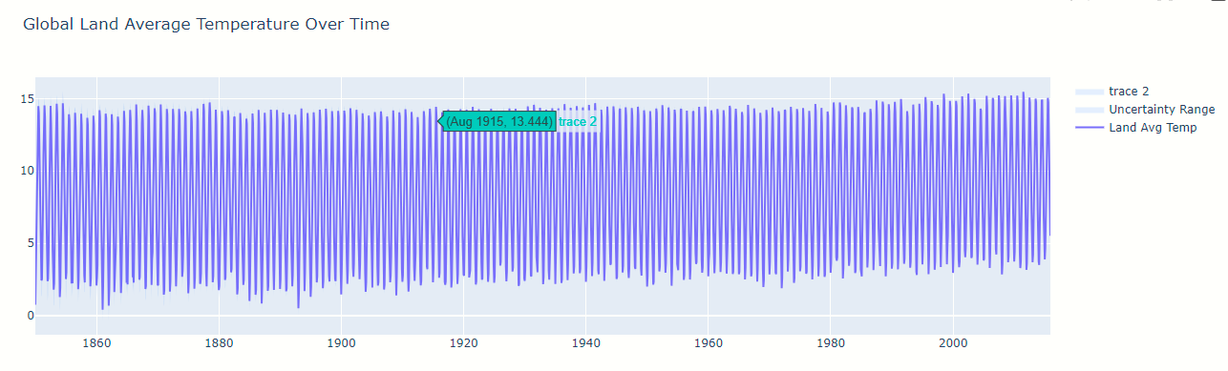

**Land Average Temperature Uncertainty:**

* Reflects the 95% confidence interval, providing a range of possible values for the recorded land temperatures.
* Helps quantify the precision of the temperature measurements, indicating how close the observed values are to the true average.
* Reduces the risk of misinterpretation by accounting for potential measurement errors or data gaps.

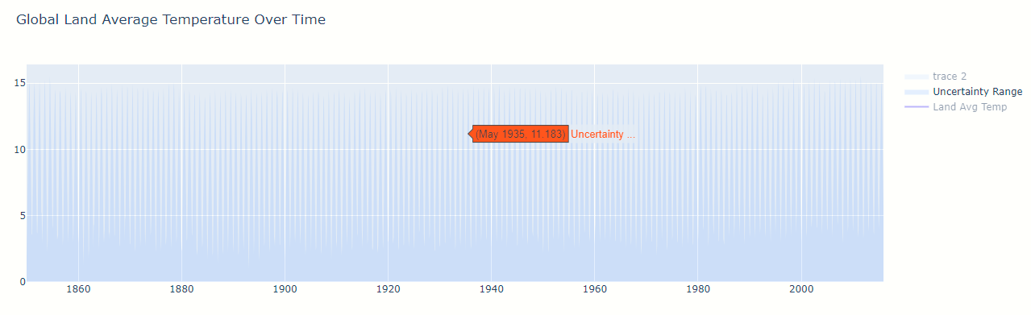 **Land Max Temperature:**

* Captures the global average of maximum temperatures recorded over land surfaces during the hottest parts of each day.
* Expressed in Celsius, it gives insight into peak temperature trends and extremes, which are crucial for assessing heat waves and their impact.
* Often used to analyze the severity of extreme temperature events and their implications on public health and agriculture.

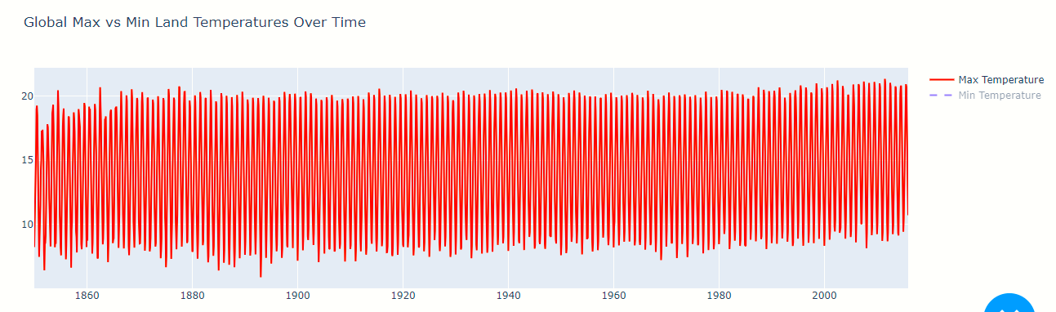

**Land Min Temperature:**

* Represents the global average of minimum temperatures recorded over land, typically during nighttime or early morning.
* Expressed in Celsius, this measure is vital for understanding frost events, cold waves, and other phenomena affecting ecosystems and infrastructure.
* It provides insights into the warming trends of cold temperatures, especially in regions experiencing reduced cooling.

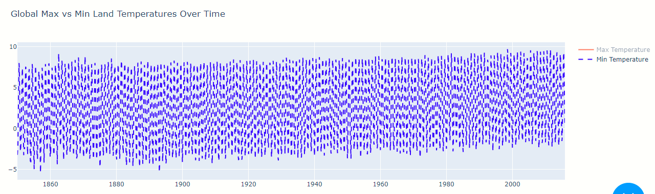

**Land Min Uncertainly Temperature:**

* Symbolizes the 95% confidence interval for the global minimum temperature readings, indicating the degree of certainty.
* Helps in evaluating the accuracy of the minimum temperature data, reducing the risk of underestimating cold temperature extremes.
* Ensures better understanding of how reliable minimum temperature trends are, particularly in climate risk assessments.

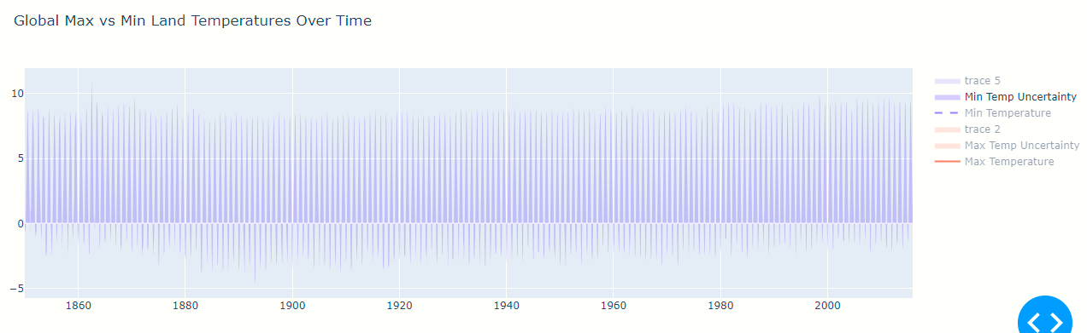

**Land Max Uncertainly Temperature:**

* Indicates the 95% certainty interval associated with the global maximum temperature readings.
* Helps assess the reliability of the maximum temperature data, showing how much the actual max temperatures may vary from reported values.
* Useful for ensuring confidence in extreme temperature trend analysis, especially in understanding anomalies.

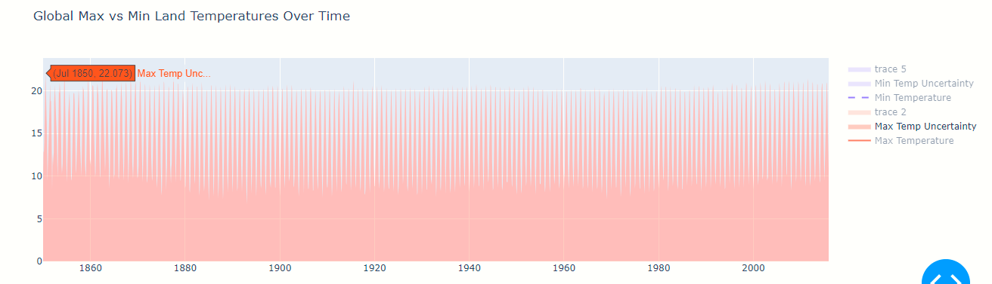

**Land And Ocean Average Temperature:**

* Represents the global combined average of both land and ocean temperatures, measured in Celsius.
* It serves as one of the most comprehensive indicators of global climate change, accounting for temperature changes across all Earth's surfaces.
* Useful for detecting broader climate patterns, as oceans have a moderating effect on global temperature trends, while land surfaces show sharper variations.

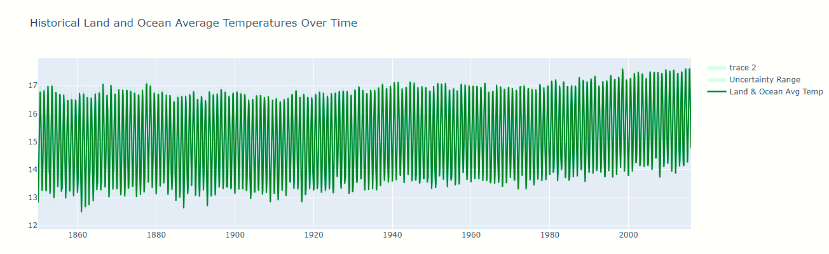

**Land And Ocean Average Temperature Uncertainty:**

* Represents the 95% confidence interval associated with the combined global land and ocean temperature measurements.
* Provides a margin of error for the average global temperature, reflecting how certain the blended land and ocean temperature estimates are. This uncertainty helps improve the reliability of climate analysis.
* Ensures that reported temperatures include potential data inaccuracies, giving a fuller picture of temperature variations and providing more cautious projections of global climate trends.

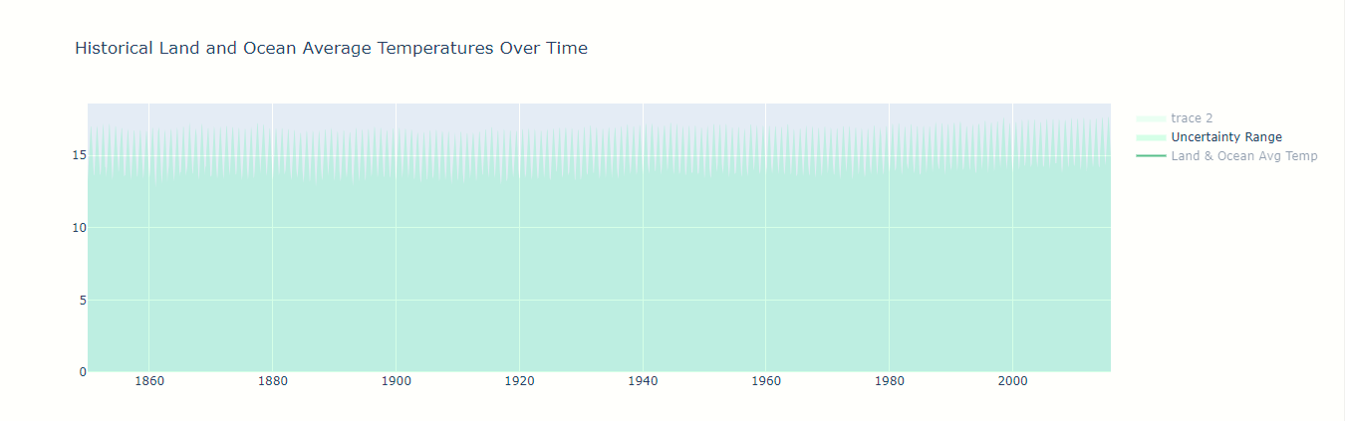

**Actual Data**

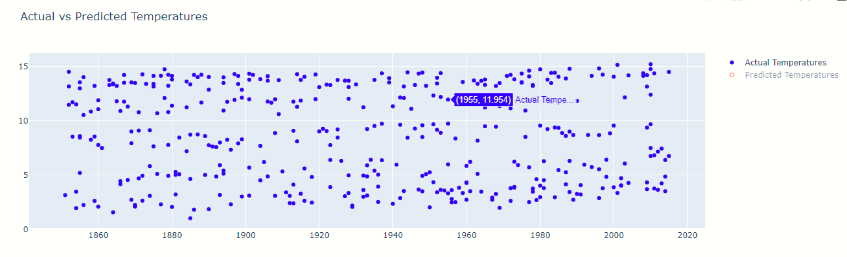

**Predict Data**

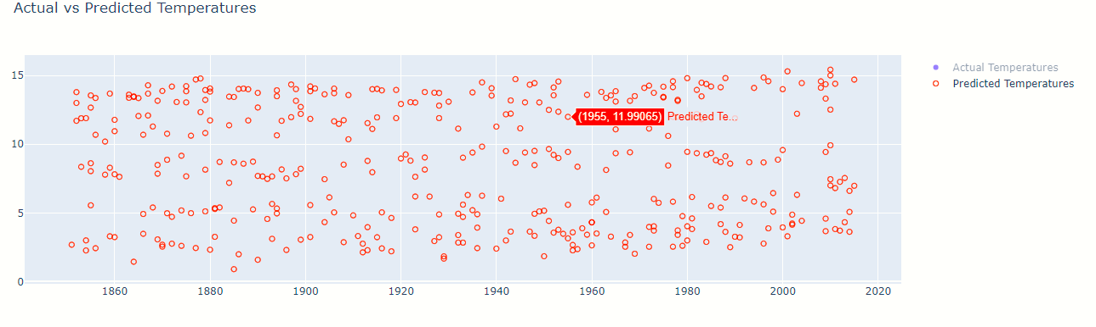

**Actual VS Predict Temperature**

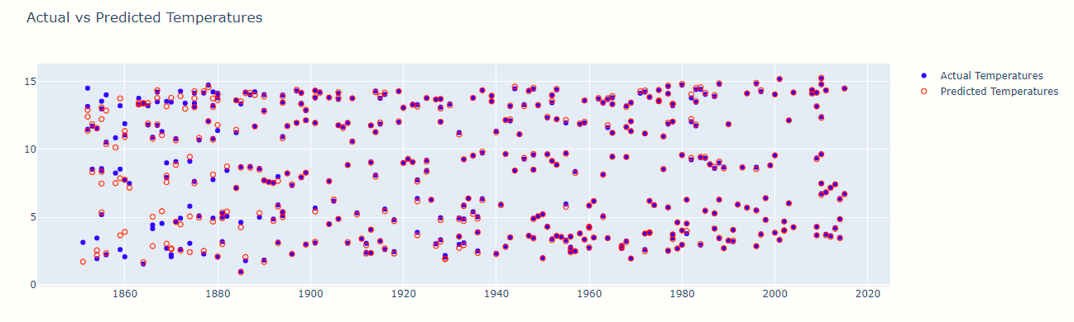

**Predict by Search**

**Result of Prediction (Result 1)**

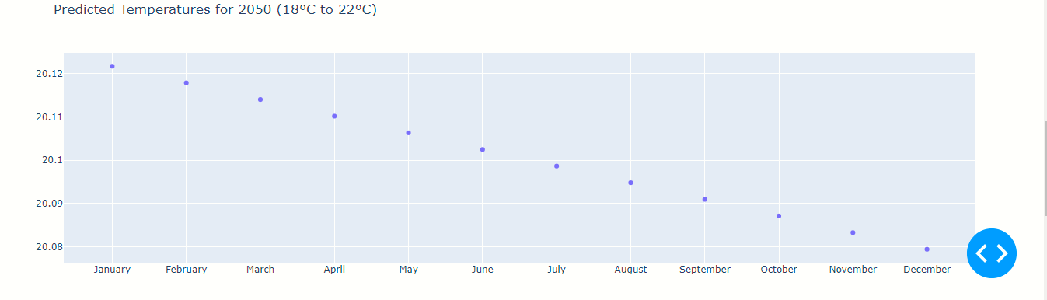

**Result of Prediction (Result 2)**

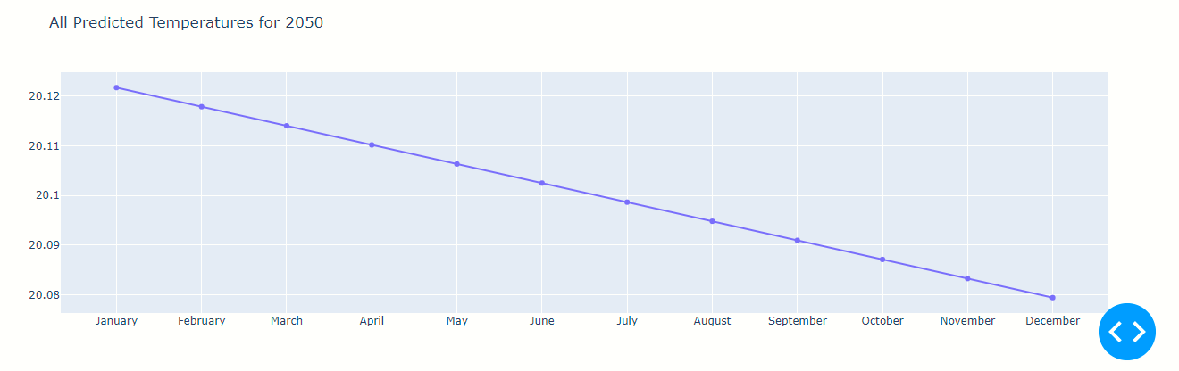

**Dialog Flow**

**Working Flow Chart**

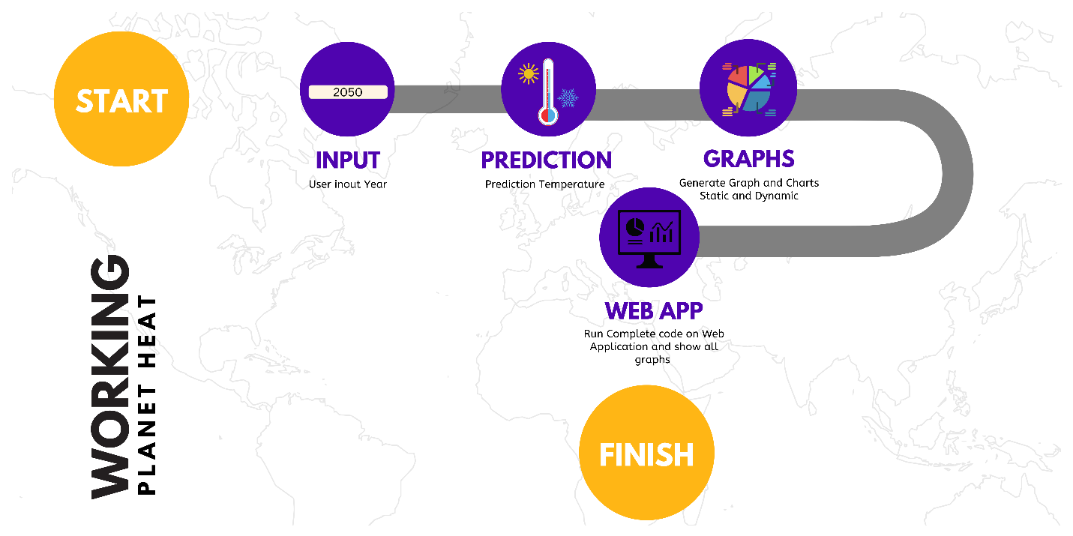

**Test Data Used in the Project**

* **Dataset:** GlobalTemperatures.csv containing historical temperature records, including:
  + Date
  + Land Average Temperature
  + Land Max Temperature
  + Land Max uncertain Temperature
  + Land Min uncertain Temperature
  + Land Min Temperature
  + Land and Ocean Average Temperature

**Project Installation Instructions**

1. **Clone the Repository:** Clone the GitHub repository to your local machine.

bash

Copy code

git clone https://github.com/umair132code/aptech_orangi_techwiz5.git

1. **Navigate to the Project Directory:**

bash

Copy code

cd PlanetHeat

1. **Install Required Libraries:** Ensure you have Python installed, then run:

bash

Copy code

pip install -r requirements.txt

1. **Add the Dataset:** Place the GlobalTemperatures.csv file in the project directory.

**Steps to Execute the Project**

1. **Run the Application:** In your terminal, navigate to the project directory and execute:

bash

Copy code

python app.py

1. **Open Web Browser:** Navigate to http://127.0.0.1:8050/ to access the application.
2. **Input Year:** Enter a year between 1750 and 2100 to see temperature predictions and visualizations.